Smart Parking Platform Project - $oftware ¢orp.
Homework 4
Gerardo Vera
CIS 4374
October 1st, 2026

- Risk Lists
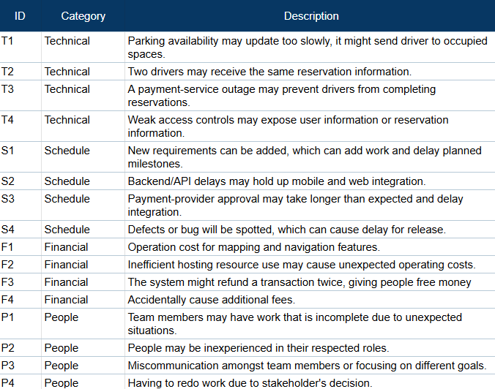
- Risk Register
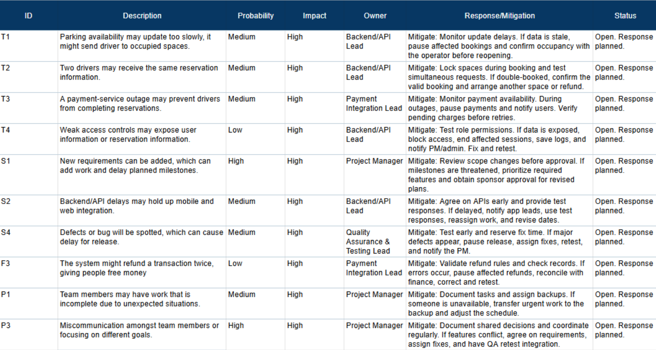

- Communication Plan
